Finance Documents

Accounts
The Denbighshire UNISON branch accounts have been audited and agreed by Sailsbury accountants. The ARF certificate is awaiting the signature of the Managing Director of Sailsburys before submission to UNISON national on Monday 10 March.

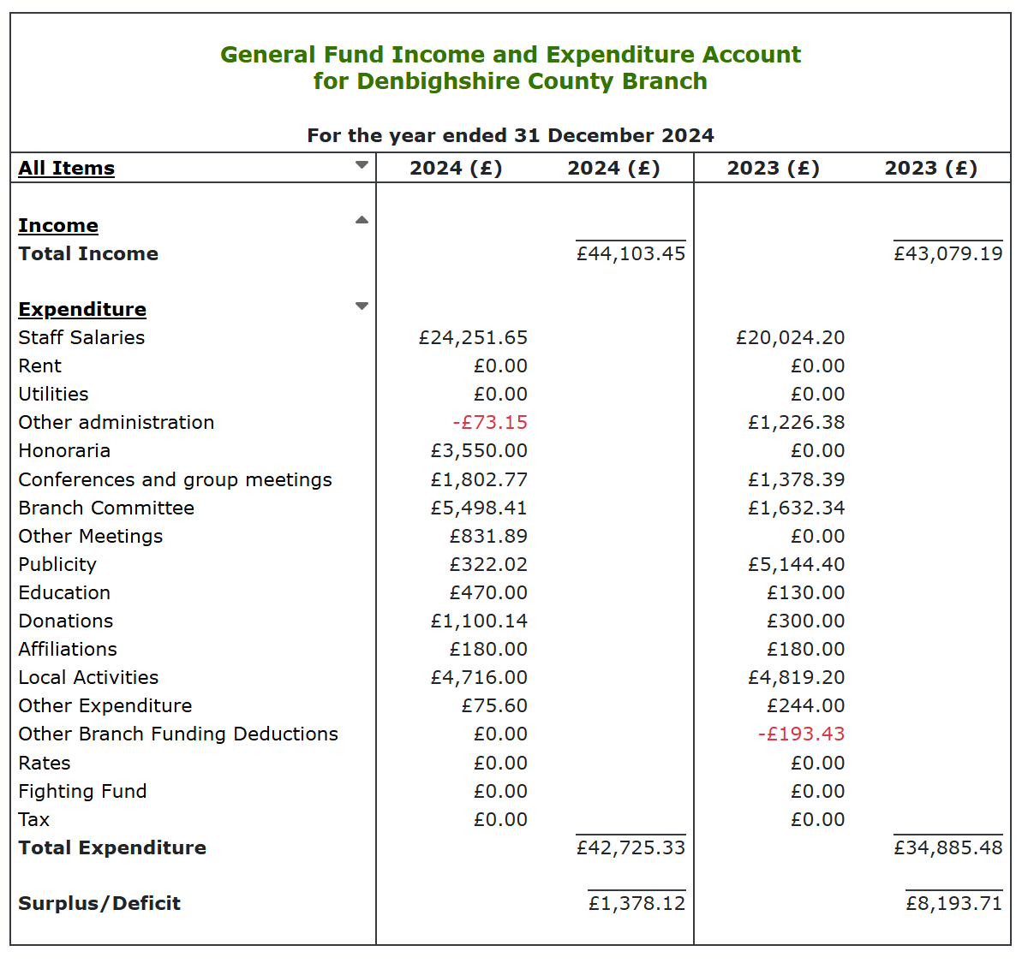

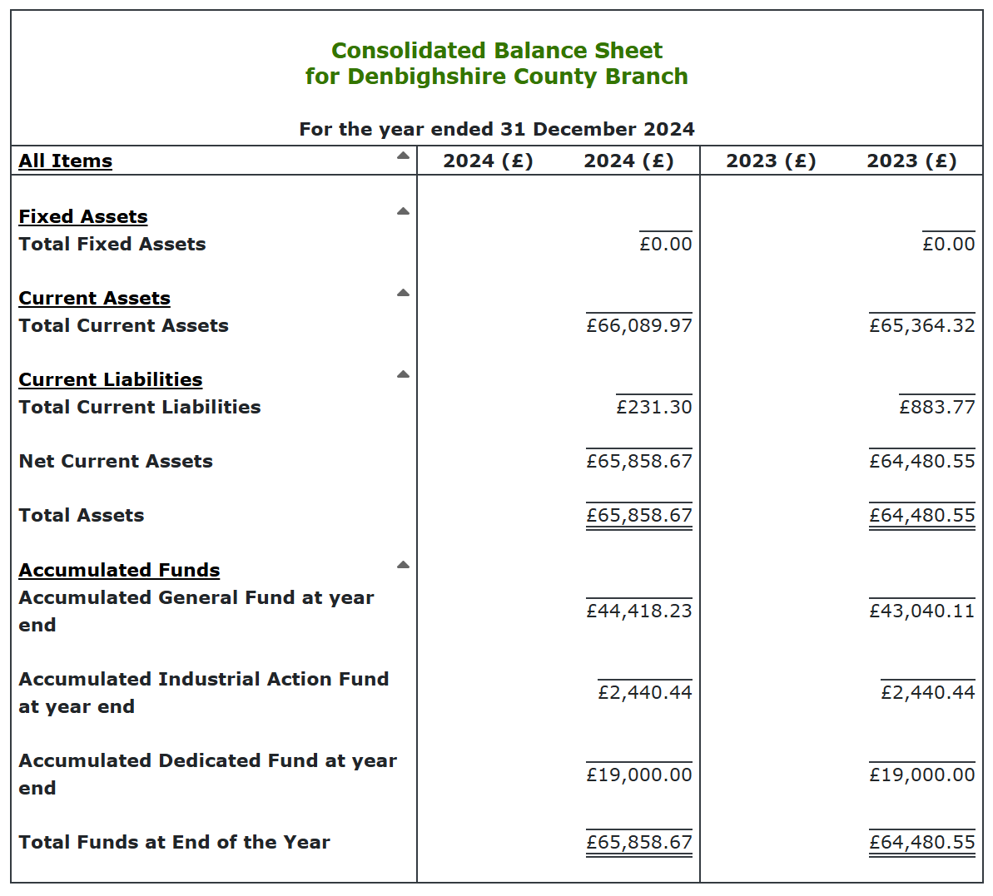

Budget 2025
Name |  | 2025
Branch Funding | Income | £ 38,933.37
Other Income | Income | £ 6,575.00
 |  | £ 45,508.37
Administration | Expenditure | £ 2,000.00
Affiliations | Expenditure | £ 200.00
Communications | Expenditure | £ 240.00
StaffingBES | Expenditure | £ 26,500.00
Participation_National | Expenditure | £ 1,420.00
Participation_Region | Expenditure | £ 2,880.00
Education | Expenditure | £ 1,000.00
StaffingSecondment | Expenditure | £ 3,000.00
Participation_Branch | Expenditure | £ 3,000.00
Local Activities | Expenditure | £ 3,500.00
Recruitment | Expenditure | £ 750.00
Publicity | Expenditure | £ 1,000.00
 | Remainder | £ 18.37
 |  | £ 45,508.37

